Interview Page 5

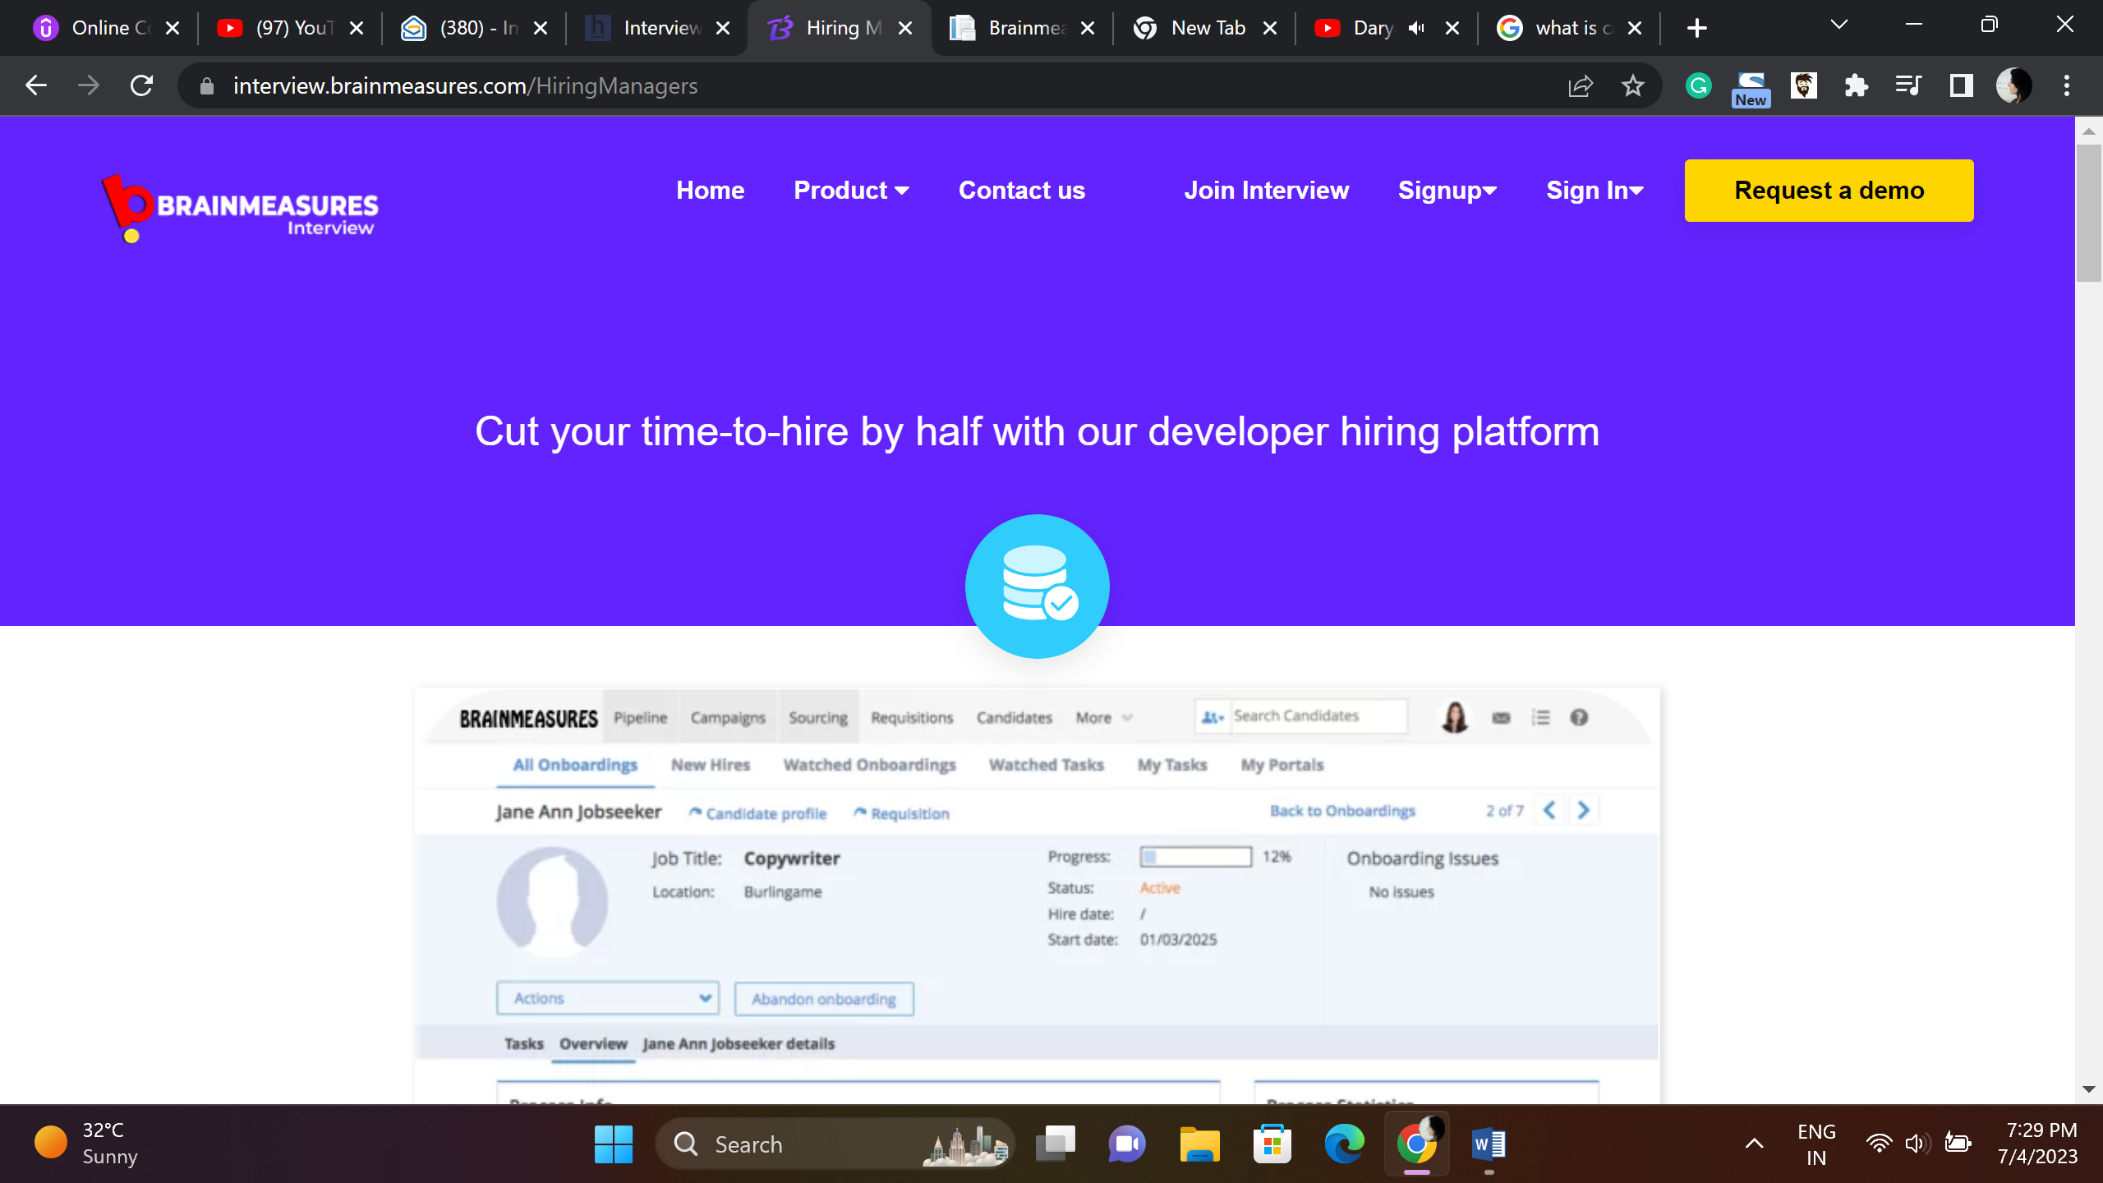

Hiring Dev?

Reduce efforts and increase your efficiency – Brainmeasures a Perfect Tech Hiring Platform

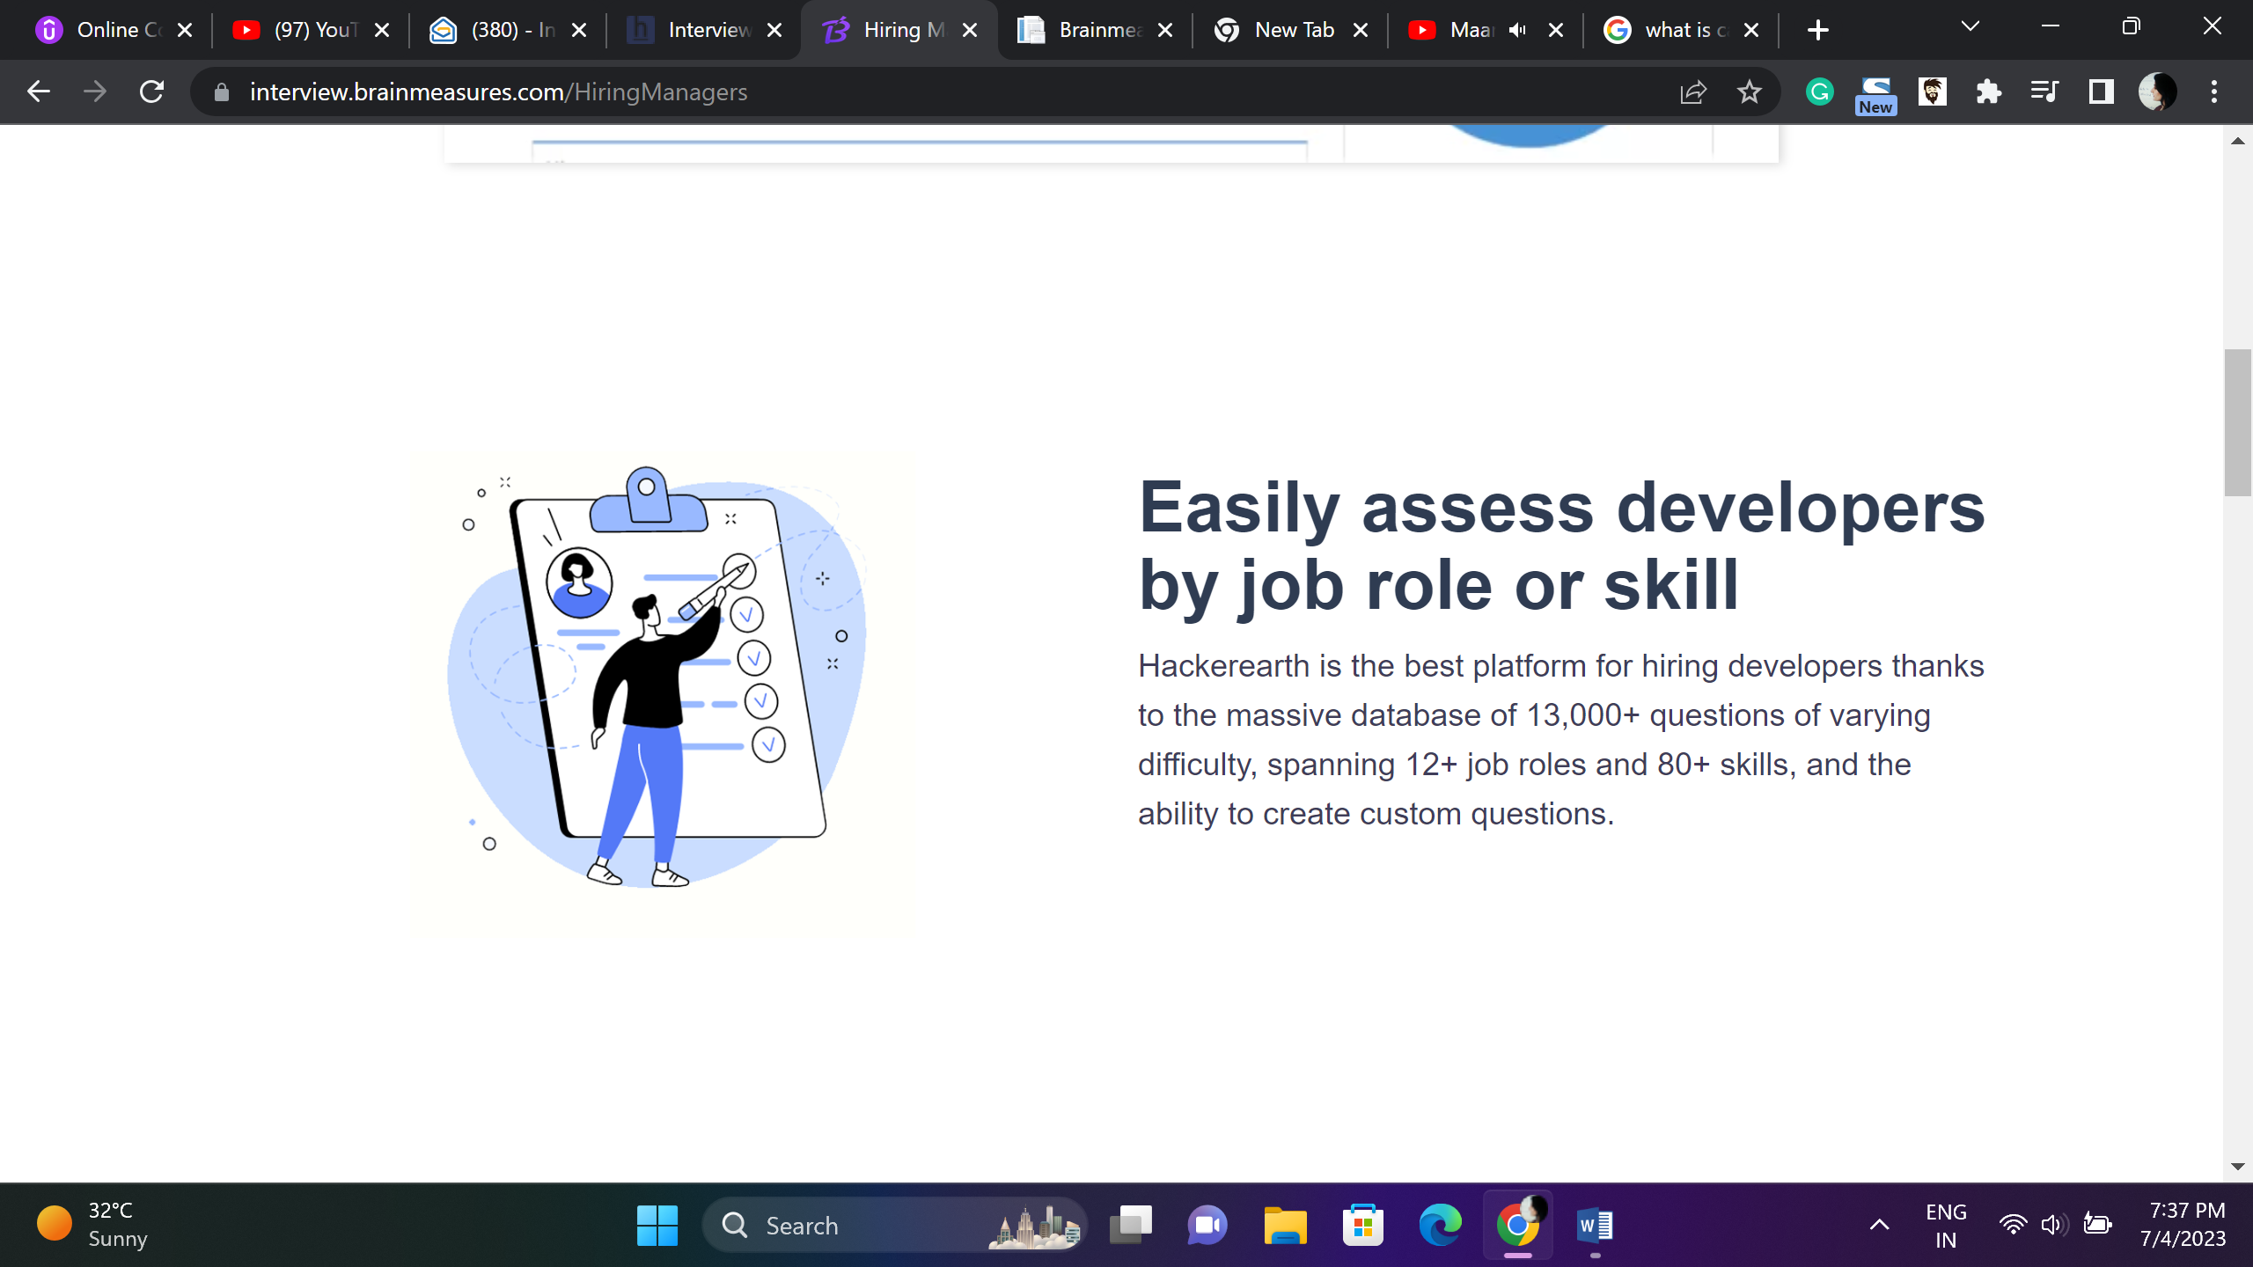

Developer Assessment Simplified – based on skill and job role

Tech Hiring Platform developed for recruiter and hiring managers loaded with recruiter friendly features such as 15k plus skill testing question repository based on array of skills, different difficulty levels, various job roles, customization friendly.

A one-stop destination to Hire, Retain and Up-Skill.

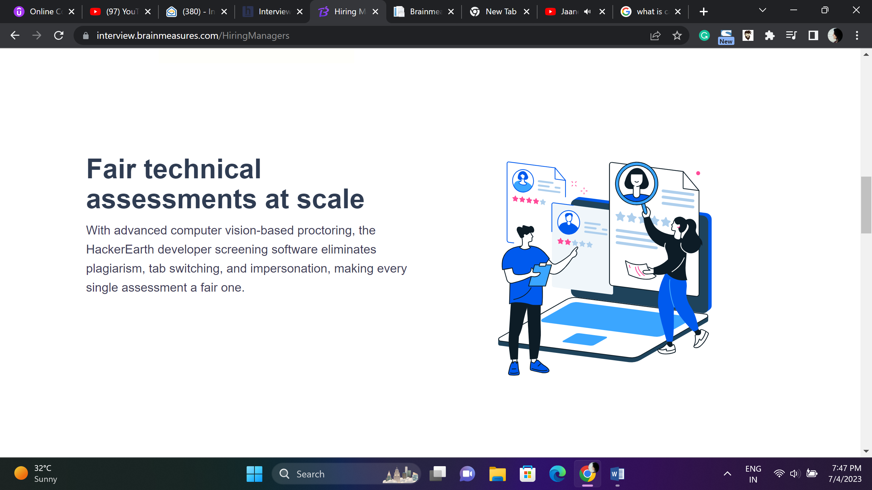

Enterprise Grade Hiring Platform

Loaded with advanced tools like automatic and human proctoring. Brainmeasures employee hiring, skill testing, learning and development platform is all you need to hire and retain talent.

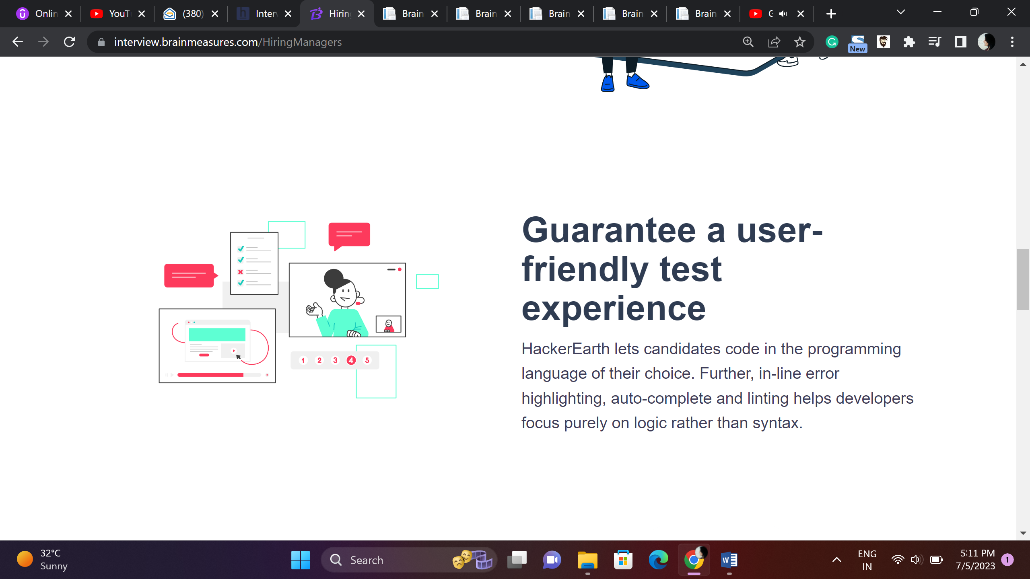

Phenomenal User Friendly Interface for Incredible Skill Testing

Coding platform that supports 50+ languages letting candidates code in the language of their choice, features like linting and autocomplete assist candidates to work on logic and not syntax.

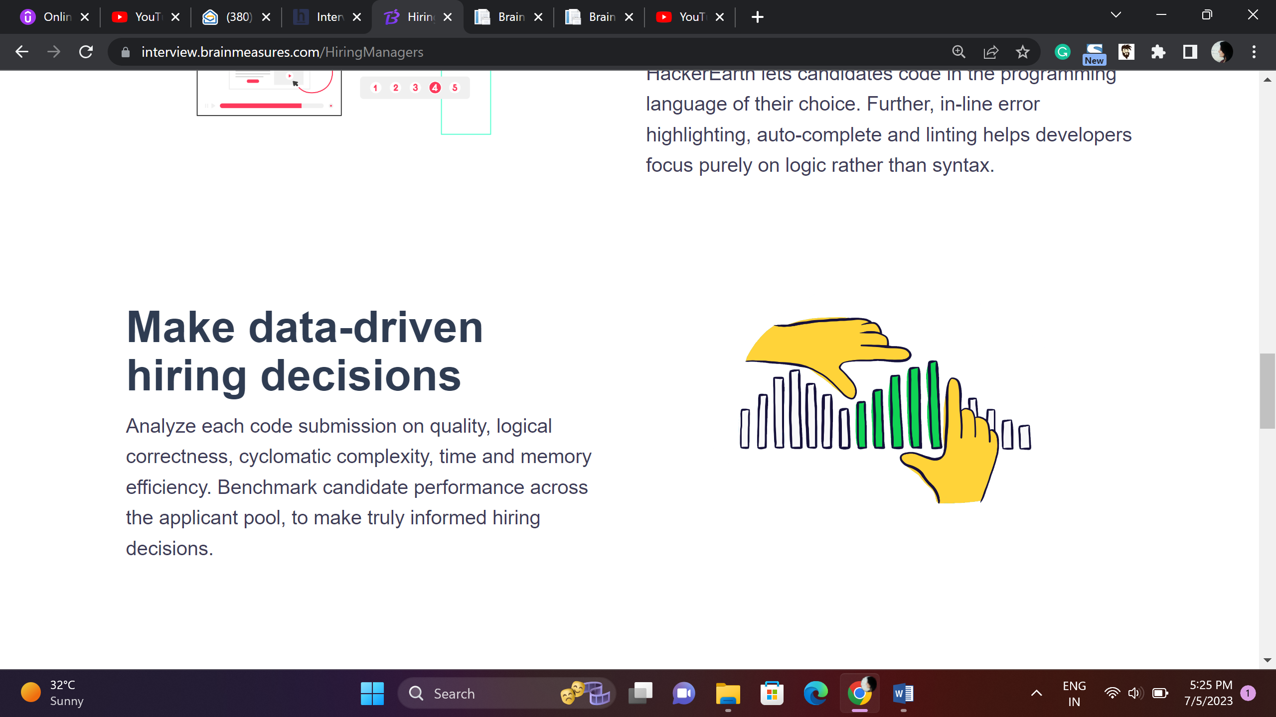

Make decisions backed by data

Detailed, in-depth analytic reports generated on code submission guide you to take decisions backed by data, set industry benchmark by making data driven and infirmed hiring decisions.

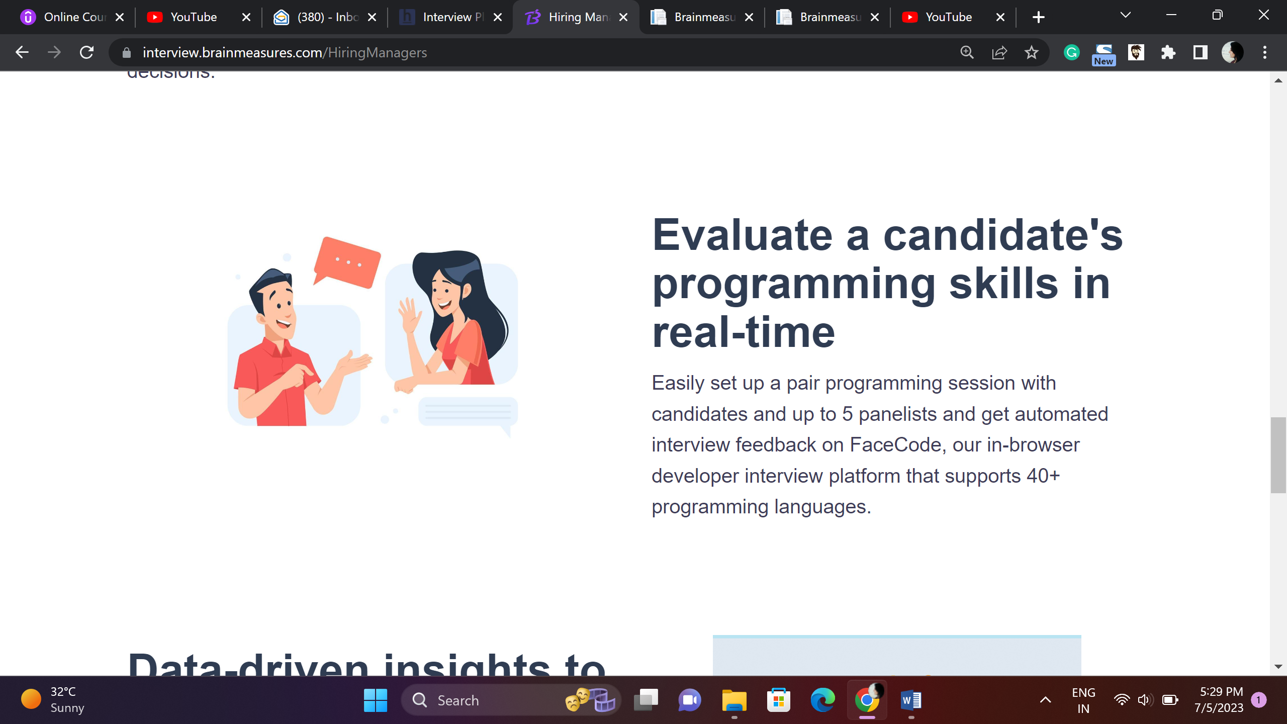

Real-time skill assessment

FaceCode, an in-browser developer interview platform that supports 50+ programming languages, makes it simple to organize a pair programming session with candidates and up to 5 panelists and receive automated real-time interview feedback.

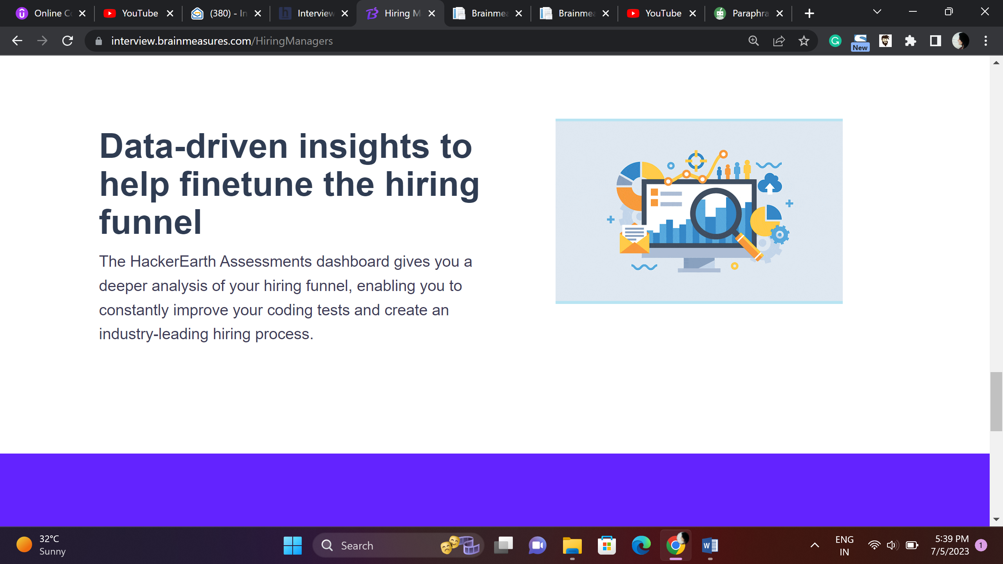

Streamline the hiring pipeline

Use data driven analytic reports, detailed candidate performance dashboards, visual insights constantly direct hiring mangers to up their hiring game by creating challenging tests which get better with each usage helping you build an industry-leading hiring process.

